Activity - Sizing Up the Universe

Introduction
The distance between objects in space is difficult to imagine. We commonly measure distance on Earth in inches, feet, and miles. The scale of outer space is so great that it requires a different unit of measure: the light-year. A light-year is the distance that light travels in one year, about 6 trillion miles.

The purpose of this activity is to gain an appreciation for the enormous dimensions of space.

Equipment
- Computer with access to the Smithsonian website

Procedure
- Go to the Smithsonian website to begin your space dimension simulation. http://www.smithsonianeducation.org/idealabs/universe/index.html

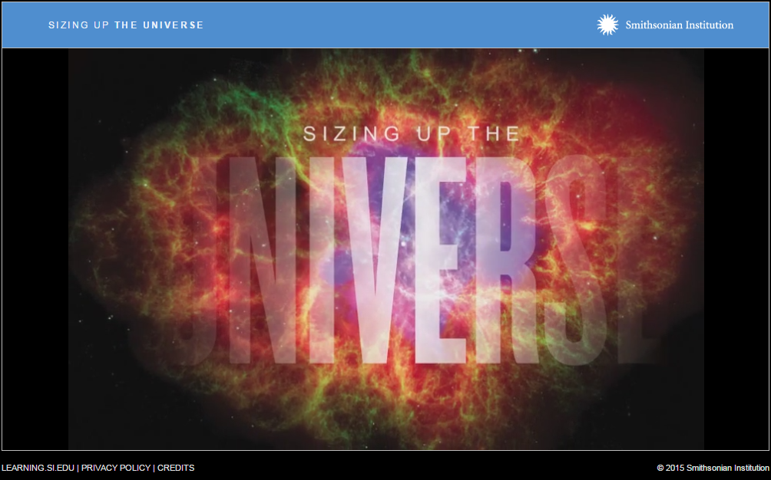
Smithsonian Institution Sizing Up the Universe

- Answer the questions and view the information in this self-directed resource.
- Print the screen for step 7, which will simulate the orbit of Pluto.
- Print the screen for step 12, which will simulate the relative size of the Milky Way galaxy.

Conclusion
- Explain the complications that can arise when traveling to some of these distant planets.

