GPS Navigational Chart Creation

Introduction
The mapping area is an outdoor area that has been defined by your teacher. Your teacher will identify the object and locations of interest.
Equipment
- Garmin eTrex Venture® HC GPS Unit
- GPS Coordinate entry chart

Procedure
- Obtain Garmin eTrex Venture ® GPS unit and owner’s manual from your teacher.
- Identify the buttons and functions below on the GPS unit. Read the description of each button’s function in the owner’s manual.
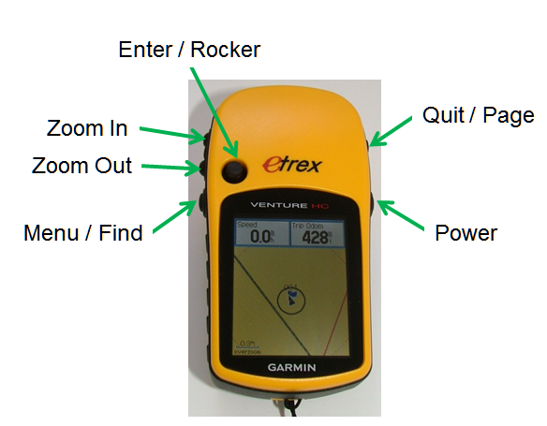

- Become familiar with capturing waypoint information using the Garmin eTrex Venture ® GPS unit.
The Garmin eTrex Venture® HC GPS unit provides two methods for capturing a waypoint. The first method, instantaneous sampling, records a location at a moment in time, while the second, average sampling, accumulates data over a period of time. In this activity you will perform both methods of capturing waypoint location information.

Instantaneous Sampling identifies a GPS unit’s location at a specific moment in time based on constantly updated satellite information calculations. The GPS unit captures its current location or waypoint at the exact moment in time specified by the GPS unit user, typically initiated by a momentary pressing of an interface button. Instantaneous sampling provides low quality location information because object position is limited to that the specific moment in time the GPS unit logged the data.

Procedure:
  - Press and hold the Enter until the Mark Waypoint page appears
  - Highlight OK
  - Press Enter

Averaging Sampling (Sampling over Time) identifies a GPS unit’s location based on numerous data points collected over a period of time. With each data point collected, random errors are diminished and the final location data becomes more accurate because it is based on the average of the logged data. To create reliable location data the GPS unit must remain fixed and unmoving for the entire duration of the data collection period.

Procedure:
  - Press and hold the Enter until the Mark Waypoint page appears.
  - Highlight Avg
  - Press Enter
  - Collect data for one minute
  - After one minute press Enter to save the waypoint

Conclusion
- What is a waypoint? How are they typically used? How can they be used to create a navigational chart?

- How accurate is a GPS unit at providing a location for an object?

Waypoint Identification Table
Waypoint | Type | Longitude |  |  | Latitude |  |  | Method  Avg.
 |  | Direction | Degrees | Minutes | Direction | Degrees | Minutes

Waypoint Identification Table (Page 2)
Waypoint | Type | Longitude |  |  | Latitude |  |  | Method  I or A(x)
 |  | Direction | Degrees | Minutes | Direction | Degrees | Minutes

