Intro to Aviation – How Wings Work

Introduction
The cross-section of a wing is called an airfoil and this shape causes changes in the flow, speed and the pressure of the air moving past it. These changes create an upward force called lift.

Four things affect an airfoil’s ability to create lift: shape, angle of attack, airspeed and air density. An airfoil’s ability to create lift is measured by its lift to drag (or L/D) ratio.

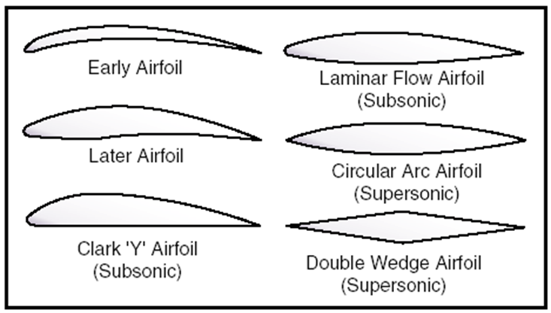

Procedure
The following procedure is meant to guide you.

- Go to the below listed website and select each type of aircraft and determine what is the best lift to drag (L/D) ratio for each. Adjust the angle of attack and speed (if applicable) to achieve the best lift to drag ratio.

http://howthingsfly.si.edu/activities/how-wings-work

- Complete the table with the Lift to drag ratio and highlight the Angle of Attack that provides the best lift to drag (L/D) ratio below:
AIRCRAFT | ANGLE OF ATTACK | SPEED | L/D RATIO
Bleriot | 0 | 76 mph
 | 5 | 76 mph
 | 10 | 76 mph
 | 15 | 76 mph

- Complete the table with the Lift to drag ratio and highlight the Angle of Attack that provides the best lift to drag (L/D) ratio below:
AIRCRAFT | ANGLE OF ATTACK | SPEED | L/D RATIO
DC-3 | 0 | 152 mph
 | 10 | 152 mph
 | 15 | 152 mph
 | 25 | 152 mph

- Complete the table with the Lift to drag ratio and highlight the Angle of Attack that provides the best lift to drag (L/D) ratio below:
AIRCRAFT | ANGLE OF ATTACK | SPEED | L/D RATIO
F-104 | 0 | 380 mph
 | 3 | 380 mph

- Complete the table with the Lift to drag ratio and highlight the Angle of Attack that provides the best lift to drag (L/D) ratio below:
AIRCRAFT | ANGLE OF ATTACK | SPEED | L/D RATIO
F-104 | 0 | 798 mph
 | 3 | 798 mph
 | 5 | 798 mph
 | 10 | 798 mph

- Complete the table with the Lift to drag ratio and highlight the Angle of Attack that provides the best lift to drag (L/D) ratio below:
AIRCRAFT | ANGLE OF ATTACK | SPEED | L/D RATIO
F-104 | 0 | 1140 mph
 | 3 | 1140 mph
 | 5 | 1140 mph
 | 10 | 1140 mph

- Complete the table with the Lift to drag ratio and highlight the Angle of Attack that provides the best lift to drag (L/D) ratio below:
AIRCRAFT | ANGLE OF ATTACK | SPEED | L/D RATIO
757 | 0 | 570 mph
 | 2 | 570 mph
 | 6 | 570 mph
 | 10 | 570 mph

Conclusion

- Explain how the Angle of Attack affects the lift to drag ratio of an airfoil.

