Weight and Balance

Procedure
- Determine if the aircraft below is loaded within the manufacturer’s recommendation. The pilot weights 185 lb and there is no co-pilot. The rear seat passengers weigh 231 and 296 lb. There is 88 lb of baggage and 68 lb of fuel onboard.
NOTE: All passengers, baggage and fuel must remain on board.

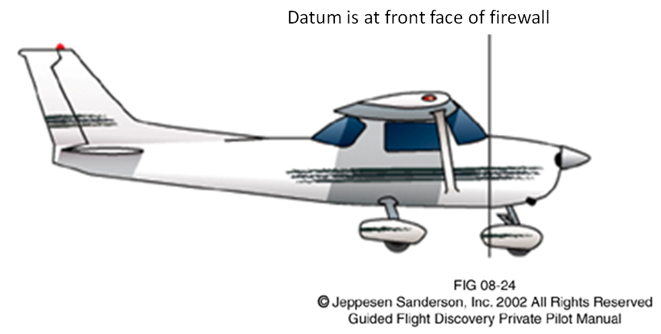

Item | Force  Weight (lb) | Distance  Arm (in.) | Moment (in.-lb)  M = Fd  M = weight ● arm
Empty Weight | 1,460 | 37.4
Pilot |  | 37.0
Co-Pilot |  | 37.0
Fuel |  | 45.3
Rear seat passenger(s) |  | 72.8
Baggage |  | 94.9
Total

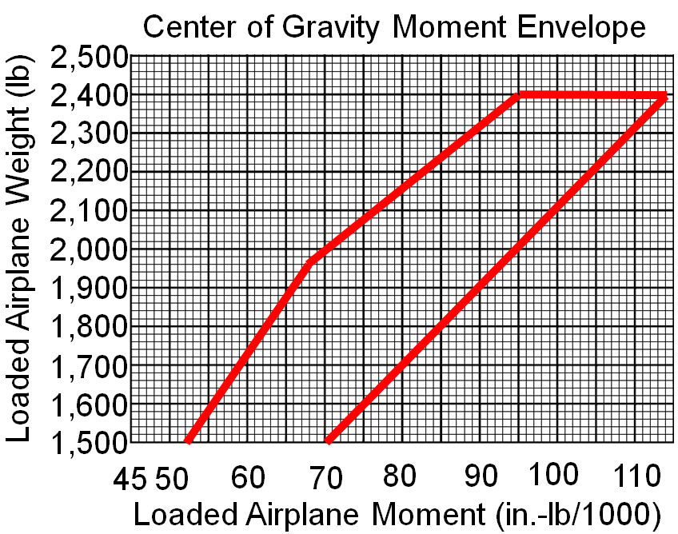

- If the aircraft is not loaded according to the manufacturer’s recommendation then suggest an alternative loading scenario so that the aircraft is safely loaded.
Item | Force  Weight (lb) | Distance  Arm (in.) | Moment (in.-lb)  M = Fd  M = weight ● arm
Empty Weight | 1,460 | 37.4
Pilot |  | 37.0
Co-Pilot |  | 37.0
Fuel |  | 45.3
Rear seat passenger(s) |  | 72.8
Baggage |  | 94.9
Total

- Determine if the aircraft below is loaded within the manufacturer’s recommendation. The pilot weights 215 lb and co-pilot weights 154 lb. The rear seat passengers weigh 181 and 196 lb. There is 107 lb of baggage and 76 lb of fuel onboard.
NOTE: All passengers, baggage and fuel must remain on board.

Item | Force  Weight (lb) | Distance  Arm (in.) | Moment (in.-lb)  M = Fd  M = weight ● arm
Empty Weight | 1,460 | 37.4
Pilot |  | 37.0
Co-Pilot |  | 37.0
Fuel |  | 45.3
Rear seat passenger(s) |  | 72.8
Baggage |  | 94.9
Total

- If the aircraft is not loaded according to the manufacturer’s recommendation then suggest an alternative loading scenario so that the aircraft is safely loaded.
Item | Force  Weight (lb) | Distance  Arm (in.) | Moment (in.-lb)  M = Fd  M = weight ● arm
Empty Weight | 1,460 | 37.4
Pilot |  | 37.0
Co-Pilot |  | 37.0
Fuel |  | 45.3
Rear seat passenger(s) |  | 72.8
Baggage |  | 94.9
Total

- Determine if the aircraft below is loaded within the manufacturer’s recommendation. The pilot weighs 235 lb and the co-pilot weighs 182. The rear seat passengers weigh 131 and 196 lb. There is three pieces of luggage – each weighing 35, 46, 27 lbs and 93 lb of fuel onboard.

Item | Force  Weight (lb) | Distance  Arm (in.) | Moment (in.-lb)  M = Fd  M = weight ● arm
Empty Weight | 1,460 | 37.4
Pilot |  | 37.0
Co-Pilot |  | 37.0
Fuel |  | 45.3
Rear seat passenger(s) |  | 72.8
Baggage |  | 94.9
Total

- If the aircraft is not loaded according to the manufacturer’s recommendation then suggest an alternative loading scenario so that the aircraft is safely loaded.
Item | Force  Weight (lb) | Distance  Arm (in.) | Moment (in.-lb)  M = Fd  M = weight ● arm
Empty Weight | 1,460 | 37.4
Pilot |  | 37.0
Co-Pilot |  | 37.0
Fuel |  | 45.3
Rear seat passenger(s) |  | 72.8
Baggage |  | 94.9
Total

- Determine if the aircraft below is loaded within the manufacturer’s recommendation. The pilot weights 178 lb and there is no co-pilot. The rear seat passengers weigh 215 and 292 lb. There is 198 lb of baggage – 4 separate bags (98, 50, 20 and 30 lbs) and 96 lb of fuel onboard.

Item | Force  Weight (lb) | Distance  Arm (in.) | Moment (in.-lb)  M = Fd  M = weight ● arm
Empty Weight | 1,460 | 37.4
Pilot |  | 37.0
Co-Pilot |  | 37.0
Fuel |  | 45.3
Rear seat passenger(s) |  | 72.8
Baggage |  | 94.9
Total

- If the aircraft is not loaded according to the manufacturer’s recommendation then suggest an alternative loading scenario so that the aircraft is safely loaded.
Item | Force  Weight (lb) | Distance  Arm (in.) | Moment (in.-lb)  M = Fd  M = weight ● arm
Empty Weight | 1,460 | 37.4
Pilot |  | 37.0
Co-Pilot |  | 37.0
Fuel |  | 45.3
Rear seat passenger(s) |  | 72.8
Baggage |  | 94.9
Total

Conclusion
- What factors will affect the center of gravity and weight and balance of an aircraft?

- Explain why calculating the weight and balance of an aircraft is so important?

