NAME_________________________________ DATE____________

Airplane Parts/Functions Worksheet
Using http://www.grc.nasa.gov/WWW/k-12/airplane/airplane.html, answer the following questions. The motion of all airplane parts is as if you were looking at the airplane from the front.
- What are the names of the parts of the airplane?
  - A:_____________________________________________
  - B:_____________________________________________
  - C:_____________________________________________
  - D:_____________________________________________
  - E:_____________________________________________
  - F:_____________________________________________
  - G:_____________________________________________
  - H:_____________________________________________
  - I:_____________________________________________
  - J:_____________________________________________
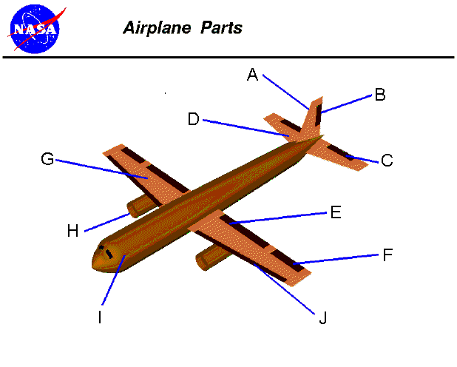
- What are the functions of the parts of the airplane?
  - A:_____________________________________________
  - B:_____________________________________________
  - C:_____________________________________________
  - D:_____________________________________________
  - E:_____________________________________________
  - F:_____________________________________________
  - G:_____________________________________________
  - H:_____________________________________________
  - I:_____________________________________________
  - J:_____________________________________________

- What are the three types of wing placement?

- What are the three types of landing gear arrangements?

