Air Traffic Control

Introduction
Air Traffic Controllers are a crucial part of a complex system intent on making flying safe. ATC decisions account for many variables, including aircraft performance, airport capacity, and weather.

In this activity you will become an air traffic controller and coordinate a group of aircraft to fly along a route safely.

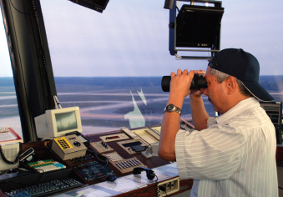

Equipment
- PC with Internet access
- Engineering notebook
- Pencil
- Calculator

Procedure
- Start the PC and open a web browser.
- Go to the NASA Traffic Control Simulator website: https://www.atcsim.nasa.gov/simulator/sim2/sector33.html
- Complete ATC Simulations2.1, 2.3, 2.6, 3.6, 4.8 and 5.6
- Change the velocities of each flight to avoid a midair collision. Change the velocities by selecting the arrow beside the velocity and clicking the new velocity.
- Click the Play button to test your proposal. Note that the scenario speed can be increased by clicking the 4X or 10X button .
- Did the aircraft pass through the MOD VOR safely? If so, congratulations on being a successful ATC. Make a screen capture of the end of the scenario with the slowest aircraft arriving at the MOD VOR.
- Submit your the screen captures of the successful arrival of flights at the MOD VOR.

Conclusion
- What variables do ATCs need to consider? What variables can they control when making decisions?

- How can the ATC system be improved?

